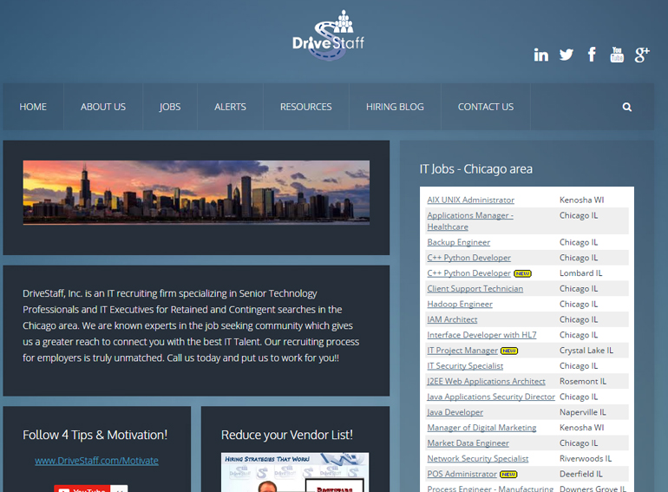

**Planned Questions and Notes:**

◻ Good Culture/People □ Can Learn/Grow □ Nice Facility/building □ Good Commute □ X-factor

**Windows PC Instructions for changing the image**

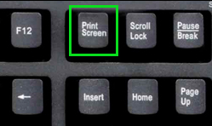**Take a Screen Capture**

Pull up your target company website in the browser of your choice.

Press the **Print Screen** button to take a picture of your screen.   
(often abbreviated as “**PRT SCR**”)

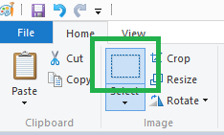**Crop the Image**

Open the **Paint** program on your PC, all Windows computers have it.

In Paint, Paste the picture you took. (right click & Paste, or press **CTRL + V**)

Click on the **Selection tool**.

On the picture, click and hold to draw a box around the part of the image you want to keep (use the image on the previous page as an example)

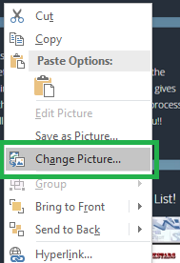Press the **Crop** button. The **Crop** button is located right next to the **Selection Tool**.

Save your image in a place where you can find it later. (Click **File>Save As** to name and save the picture)

**Insert Your New Image**

Open Interview Influencer Doc.

**Right click** on the center of the image of the DriveStaff webpage and in the dropdown that appears, click **Change Picture**.

Find the file you just created in Paint and saved and click **Insert**.

Print it out (in color if you can, not necessary though) and bring it with you!

Done! Easy Peasy, Lemon Squeezy! ☺

**How to use this**

Do NOT flaunt it or purposefully show it to the interviewers! Just pull it out on your notebook that you have with you to take notes on. THEY WILL RECOGNIZE THEIR OWN WEBSITE, even upside down from their chair!

Have your preplanned questions written out here, refer to them, ask them. They will see that.

You can change the objective boxes along the bottom, but be sure all categories are SUBJECTIVE, so you can check all boxes during any interview, with any company. Check off the boxes throughout the interview.

If they ask if you have more questions, after asking them, close your interview with, “I have 5 key things that I’m looking for in my next position, and I have to say, I’ve checked all the boxes. I hope you felt this interview went as well as I did. I would love the chance to work for you.” – Put this in your own words, but use it!